COMPLETE THE PARAGRAPH WITH THE RIGHT FORM OF THE VERBS IN SIMPLE PAST TENSE
Harry Potter _________ (BE) a very special boy. He _________ (BE) a young wizard. His hair ________ (BE) black and his eyes ________ (BE) green. He ________ (HAVE) a scar on his forehead. He ________ (LIVE) with his aunt, his uncle and his cousin. He ________ (NOT BE) happy living there because they ___________ (NOT LOVE) him.
He ________ (GET) a letter from Hogwarts School of Witchcraft and Wizardry. He ________ (BE) a new student there!! He ___________ (BUY) a new pet, too: an owl. Its name _________ (BE) Hedwig. But his uncle ____________ (NOT WANT) to have a wizard in the family and ___________ (TAKE) Harry to a lonely island.
Rubeus Hagrid ____________ (RESCUE) Harry and __________ (GO) to Diagon Alley with Harry. There he ____________ (BUY) his new clothes, books and his wand.
He ________ (GO) to school for the first time by train in Platform 9 ¾. There he __________ (MEET) his new friends: Ron Weasley and Hermione Granger. They __________ (TALK) and __________ (EAT) candies and chocolates.
They ____________ (ARRIVE) at school and __________ (HAVE) a big dinner with all the students and the teachers. A special hat (the Sorting Hat) __________ (SELECT) a house for the students. Harry, Ron and Hermione __________ (GO) Gryffindor House. They _________ (BE) very happy!
At school they __________ (TAKE) Potions classes, History of Magic classes and Defense against the Dark Arts classes. Harry also ____________ (PLAY) a sport: Quidditch. He __________ (HAVE) a broom, the Nimbus 2000, because he __________ (FLY) and __________ (CATCH) a ball, the Snitch.
Draco Malfoy ________ (NOT LIKE) Harry. He ________ (BE) a member of Slytherin House and always __________ (TRY) to beat Harry.

ANSWER THE FOLLOWING QUESTIONS
- Was Harry Potter a young wizard?
- Did he live with his mother and father?
- Did his uncle love him?
- Did Harry get a letter from Hogwarts?
- Did Snape rescue Harry Potter?
- Did Harry buy new clothes and his wand?
- Did he go to school by bus?
- Did he meet new friends in the train?
- Did the Sorting Hat select a house for the new students?
- Did Harry, Ron and Hermione go to Gryffindor House?
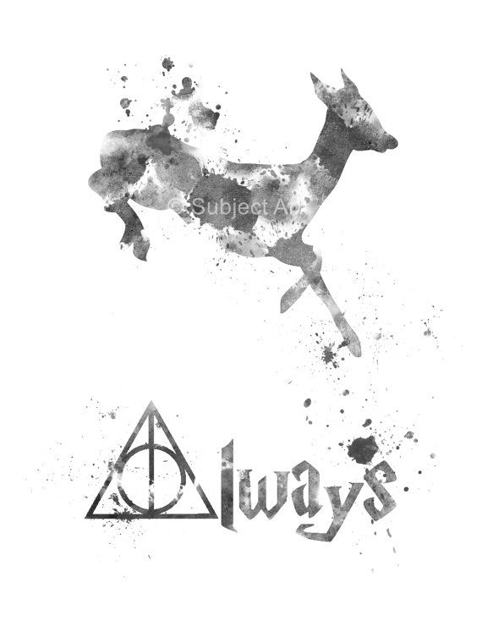
- Were they happy?
- Did they take Maths and Literature classes?
- Did Harry play a sport?
- Did Draco Malfoy like Harry?
- Was he a member of Gryffindor House, too?

